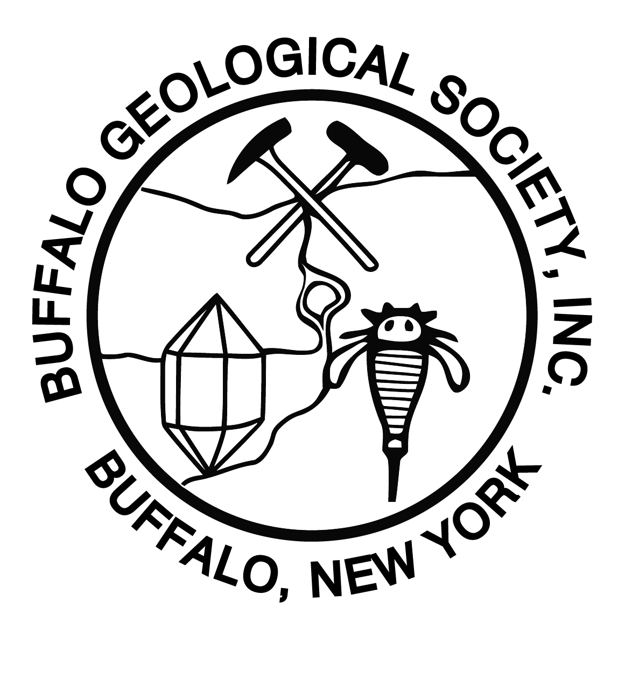
Buffalo Geological Society, Inc.
c/o Heritage Discovery Center
100 Lee Street
Buffalo, NY 14220

PRESS RELEASE
Contact: Jerry Bastedo
(716) 864-2701, jcbastedo@gmail.com

GOLD, APOLLO 15 MOON ROCK, AND LECTURES TO BE FEATURED AT

BUFFALO GEOLOGICAL SOCIETY’S
Buffalo Geological Society
c/o Buffalo Museum of Science, 1020 Humboldt Parkway, Buffalo, NY 14211

50TH ANNUAL GEM-MINERAL-FOSSIL SHOW
A moon rock, collected during the Apollo 15 lunar landing mission by Lunar Module Pilot James B. Irwin, will be a featured display at the Buffalo Geological Society’s 50th Annual Gem, Mineral and Fossil Show on March 24-25, 2018, at the Erie County Fairgrounds in Hamburg NY, on Saturday, 10 am-6 pm and Sunday, 10 am-5 pm.

The 159-gram sample was collected by Irwin, near Station 8, from a football sized moon rock and is encased in lucite. The rock is a basalt, a dark colored extrusive igneous rock formed from lava that cooled quickly on the surface of the moon. The rock contains pyroxene and plagioclase feldspar. This rock was collected with more than 170 pounds of lunar samples at the Hadley Rille on the moon during the Apollo 15 Lunar Mission in July & August 1971.

In addition, the 50th Annual Show theme is "GOLD” and there will be exhibits displaying a variety of gold specimens from several different localities. In addition several mineral dealers will have gold for sale.

There will be four lectures on Saturday and Sunday on a variety of topics in the geological sciences, as part of the admission to the show. The illustrated presentations include:

Saturday, March 24, 2018

11 am Endobionts in Pleurodictyum and 3-d scanning, by Nathan Peters
1 pm Pyrite Disease, by Miriam Eastham
2 pm Fluorescent Minerals, by Dino Zack
3 pm So you want to be a Geologist?, by Joe Butch

Sunday, March 25, 2018

11 am Dinosaur Excavations in South Dakota, by Glen Laplaca
1 pm WNY 2018 Science Congress Winner(s) in Earth Science, by Jr & Sr High School students
2 pm Gold : A discussion on the history, collection sites, and more, by Marcia Binda
3 pm Geology of Cape Cod, Massachusetts, by Jon Nickerson

This annual show provides an instant museum of Buffalo Geological Society Members fossils, minerals, and jewelry; demonstrators; the famous Mini-Mine for young collectors; mineral and fossil identification; and a variety of non-profit exhibitors. This highly educational family event affords attendees the opportunity to interact with demonstrators who work with minerals and gems. Demonstrators include stone carvers, jewelry designers, and other lapidary artists. In addition, over 30 dealers selling gems, beads, minerals, fossils, and jewelry will be selling their items from around the world. A food vendor and hourly door prizes will be available.

Sandy Cline, international renowned soapstone carver from Canada, will be demonstrating his art of carving wildlife forms and will have several for sale. Young scientists can visit the “Mini-Mine” where they will be able to search for mineral specimens in a simulated mine setting. All who attend can experience hands-on fun and learn something new about the geological sciences. Professional Geologists will be available to discuss what geologists do and what types of jobs are present in the area for geologists.

This event draws over 4,000 attendees annually. Families come from all over Western and Central New York, Pennsylvania, Ohio, and Canada to take part in this event. This is a perfect family field trip to learn more about the geological sciences. Boy Scouts, Girl Scouts, students, teachers, the public, and rock hounds are welcome. Adults are $5 each, scouts in uniform and children under 12 are FREE. Door prizes are drawn hourly. FREE parking. Wheel chair and stroller accessible. Any publicity you can provide for this event will be greatly appreciated. Thank you.
30

